Somerset Road Education Trust Gender Pay Gap 2019
Figures to publish | March 2019 |  |  |  | Figures for last year | March 2018
Mean gender pay gap | 23.05% |  |  | - a slight decrease compared to 2018 | Mean gender pay gap | 23.47%
Median gender pay gap | 31.48% |  |  | - a slight increase compared to 2018 | Median gender pay gap | 31.43%
Mean bonus gender pay gap | n/a - no bonuses paid |  |  |  | Mean bonus gender pay gap | n/a - no bonuses paid
Median bonus gender pay gap | n/a - no bonuses paid |  |  |  | Median bonus gender pay gap | n/a - no bonuses paid
Proportion of males receiving a bonus payment | n/a - no bonuses paid |  |  |  | Proportion of males receiving a bonus payment | n/a - no bonuses paid
Proportion of females receiving a bonus payment | n/a - no bonuses paid |  |  |  | Proportion of females receiving a bonus payment | n/a - no bonuses paid
Proportion of males and females in each quartile pay band | see table |  |  |  | Proportion of males and females in each quartile pay band | see table
Quartile Percentages |  |  |  |  | Quartile Percentages
 | % Female | % Male | Grand Total |  |  | % Female | % Male | Grand Total
Lower Quartile | 92.86% | 7.14% | 100.00% |  | Lower Quartile | 94.83% | 5.17% | 100.00%
Lower Middle Quartile | 92.98% | 7.02% | 100.00% |  | Lower Middle Quartile | 93.10% | 6.90% | 100.00%
Upper Middle Quartile | 85.71% | 14.29% | 100.00% |  | Upper Middle Quartile | 86.21% | 13.79% | 100.00%
Upper Quartile | 82.14% | 17.86% | 100.00% | - higher male % than 2018 | Upper Quartile | 86.21% | 13.79% | 100.00%
Grand Total | 88.44% | 11.56% | 100.00% |  | Grand Total | 90.09% | 9.91% | 100.00%
Detail for figures to publish |  |  |  |  | Detail
 | Male | Female | Pay Gap |  |  | Male | Female | Pay Gap
Mean | £18.04 | £13.88 | 23.05% |  | Mean | £18.39 | £14.08 | 23.47%
Median | £15.93 | £10.91 | 31.48% |  | Median | £15.62 | £10.71 | 31.43%
Quartile Numbers |  |  |  |  | Quartile Numbers
 | Female | Male | Grand Total |  |  | Female | Male | Grand Total
Lower Quartile | 52 | 4 | 56 |  | Lower Quartile | 55 | 3 | 58
Lower Middle Quartile | 53 | 4 | 57 |  | Lower Middle Quartile | 54 | 4 | 58
Upper Middle Quartile | 48 | 8 | 56 |  | Upper Middle Quartile | 50 | 8 | 58
Upper Quartile | 46 | 10 | 56 |  | Upper Quartile | 50 | 8 | 58
Grand Total | 199 | 26 | 225 |  | Grand Total | 209 | 23 | 232

Somerset Road Education Trust Gender Pay Gap 2019
Median values
The median is the middle value of all the staff hourly rates. Each line on the 2 charts represents an employee and their hourly rate.
The median values are highlighted in red.
This shows the larger proportion of female staff on lower grades, earning around £10 per hour or less, causing the median to occur at a lower rate.
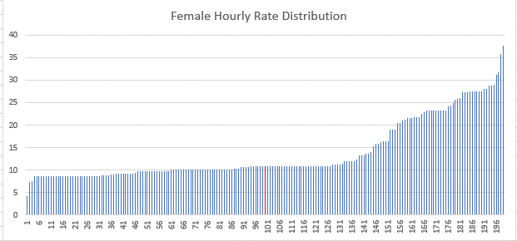 |  |  |  |  |  |  |  |  |  |  |  | 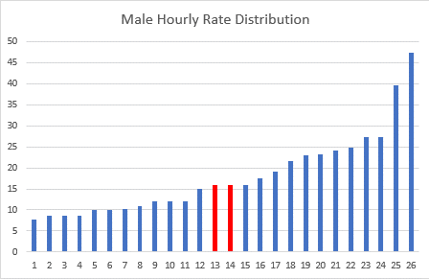
 |  | Mean | Median |  |  |  | Male | Female | Pay Gap |  |  |  | Mean | Median
 | Female | £13.88 | £10.91 |  |  | Mean | £18.04 | £13.88 | 23.05% |  |  | Male | £18.04 | £15.93
 |  |  |  |  |  | Median | £15.93 | £10.91 | 31.48%

